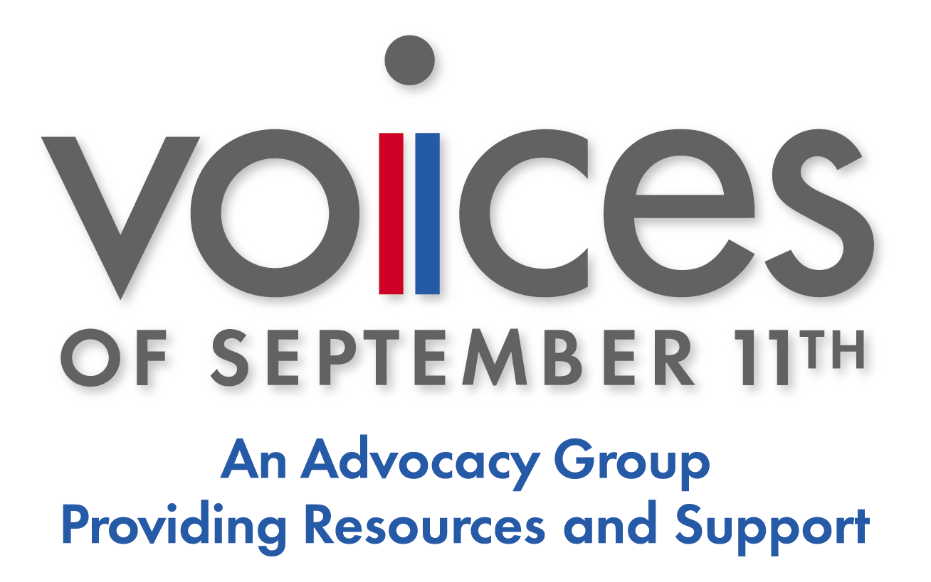

For immediate release
Contact: Debbie Westfal, 203-966-3911, dwestfal@Voicesofsept11.org

TEDDY BEARS FOR BESLAN FAMILIES

(New Canaan, CT) VOICES of September 11th, a non-profit family advocacy group serving the needs of all those affected by 9/11, is reaching out to those affected by the Beslan school attack in Russia last September. VOICES plans to send 344 teddy bears with personal notes translated in Russian to the families who lost loved ones. This gesture of good will and empathy will help commemorate the first anniversary of the Beslan attack. Mary Fetchet, Founding Director and President of VOICES of September 11th, and mother of Brad, said: “Those of us who lost a loved one on September 11 remember how meaningful it was to receive messages of support and consolation along with an international symbol of friendship like the teddy bear. Small gestures like these helped us stay strong during those trying days, and we would like to extend the same good will to the people of Beslan.” Senator Joe Lieberman of Connecticut has arranged for VOICES to present the teddy bears with personal notes to officials at the Russian Embassy in Washington on June 27.

If you would like to participate in our Teddy Bears for Beslan families, please send us a teddy bear or a check for $10.00, payable to VOICES of September 11th, at 93 Cherry Street, New Canaan, CT 06840. We would like to encourage all those participating to include a personal note of support. Volunteers will hand-write your message on a card. Inquiries should be addressed to Debbie Westfal at dwestfal@voicesofsept11.org or by phone at 203-966-3911.

VOICES of September 11th is a non-profit, non-partisan organization promoting public policy reform for prevention, preparedness and response related to terrorism. VOICES advocates and supports families and all those impacted by 9/11 and other terrorist attacks. VOICES has earned a reputation as a strong advocate for effective National Security, as well as a valuable facilitator for stronger international relationships through its Building Bridges program.

